(Eli Lilly and Pfizer) Based on Brams and Taylor (2000). Suppose that Eli Lilly and Pfizer are going to merge. Merger negotiations must settle the following issues:

* What will the name of the merged corporation be?
* Will corporate headquarters be in Indianapolis (Lilly wants this) or New York (Pfizer wants this)?
* Which company’s chairperson will be chairperson of the merged corporation?
* Which company gets to choose the CEO?
* On the issue of layoffs, what percentage of each company’s view will prevail?

Brams developed a remarkably simple method for the two adversaries to settle their differences. (This same method could be used to settle differences between other adversaries, such as a husband and wife in a divorce, Arab and Israel in Middle East, and so on.) Each adversary allocates 100 points between all of the issues. These allocations are listed in below table. For example, Lilly believes headquarters is worth 30 points, whereas Pfizer thinks headquarters is worth only 15 points. Layoffs may be divided (for example, Lilly might get 70% of the say in layoffs and Pfizer 30%), but on all other issues, only one company gets its way. The adjusted winner procedure says that the best way to make decisions on each issue is to:

* give each adversary the same number of points;
* ensure that each company prefers its allocation to the allocation of its opponent;
* maximize the number of points received by either participant.

Such a solution is equitable (because each party receives the same number of points) and is envy-free (because neither side prefers what its opponent receives to what it receives). It can also be shown that the adjusted winner procedure yields a Pareto optimal solution. This means that no other allocation can make one player better off without making the other player worse off. Find the adjusted winner solution to the merger example. Also show that the adjusted winner solution for this example is Pareto optimal.



**Discussion: -**

We can understand from problem that our solution should split the issues in favor of any of the two companies in such a way that both the companies will get equal number of points. Company with higher points will win that issue. For example, Lilly will have issue ‘Name’ in their favor and Pfizer will have issue ‘CEO’ in their favor. If we split the points on this basis, points received by each company will not be equal. Please refer to below given snapshot.

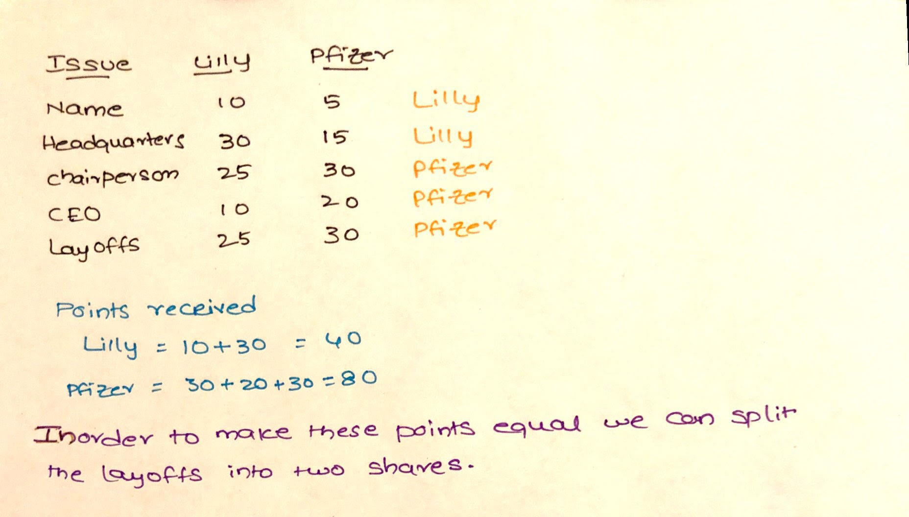

To give equal share for both the companies, we are allowing to split the layoffs (eg: 60%-40% or 70%-30%). We understand from problem that company with higher points will win that issue. How can we make sure our mathematical model picks the correct decision? Please check below snapshot which illustrates with an example.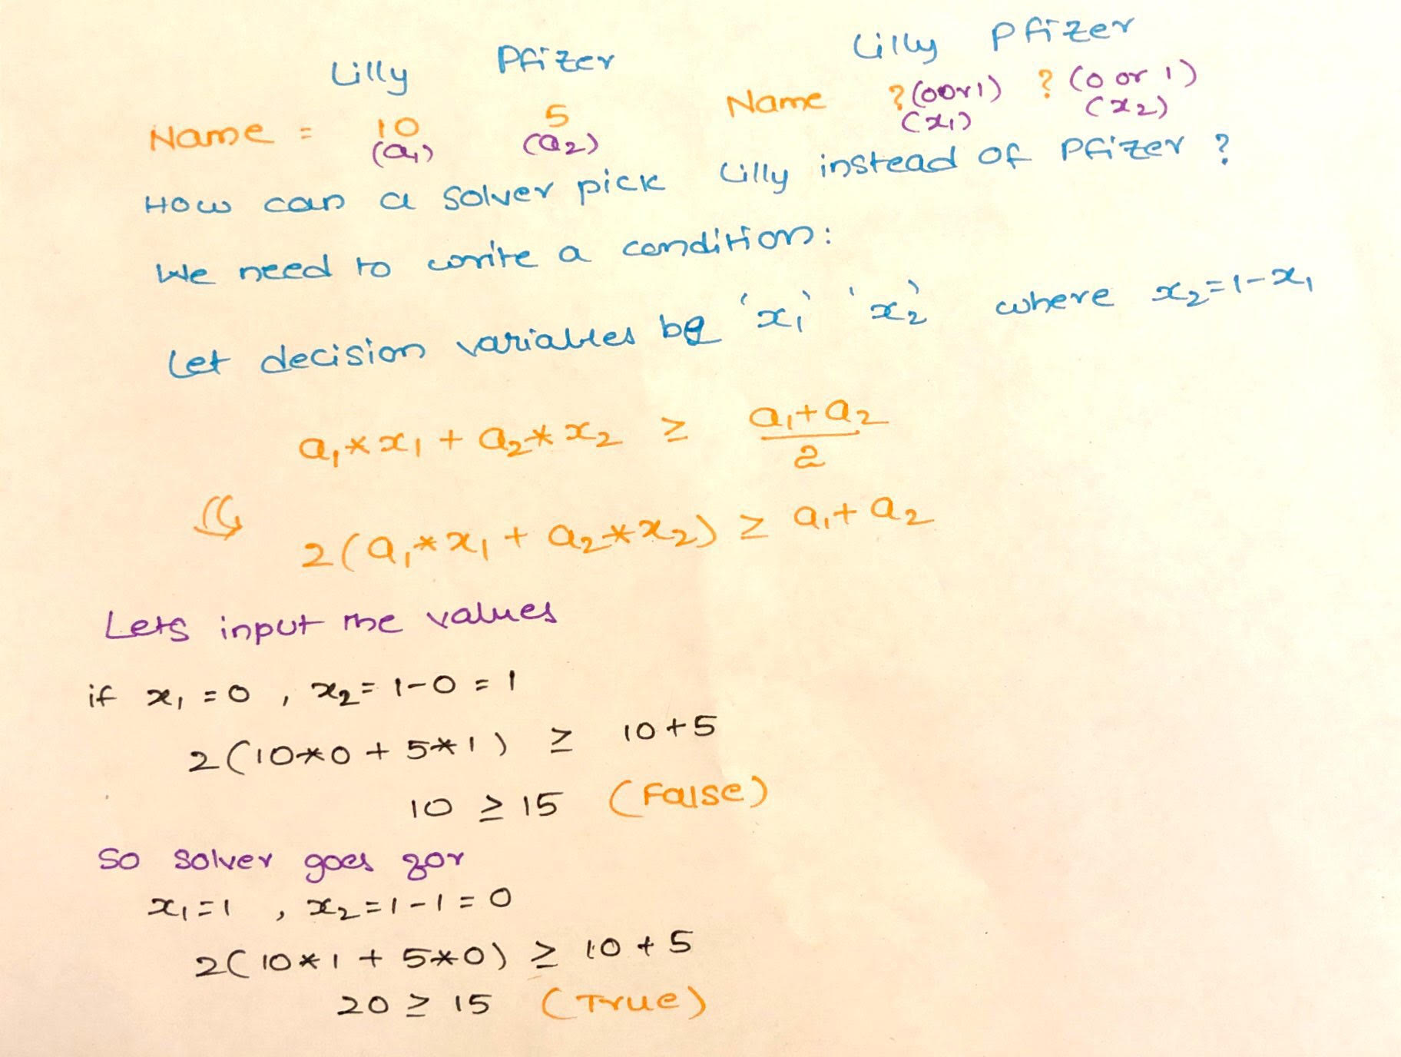

**Mathematical Model: -**

*Parameters (Inputs):*



*Decision Variables:*

*Calculated Variables:*

*Objective:*

*Constraints:*

*Excel Implementation:* Please find the attached spreadsheet for solution.

 

**Alternate Approach: -**

In the above problem we made our objective in such a way that point in favor to Lilly is equal to Pfizer. Instead of that you can change your objective to Maximize the total points in favor to Lilly and add a constraint which will make sure that points scored by both the companies are equal.

*Objective:*

*Additional Constraint:*

If the problem asks us not to consider the binary constraint on the decision variables. We can go with below solution.

**Mathematical Model: -**

*Parameters (Inputs):*

*Decision Variables:*

*Calculated Variables:*

*Objective:*

*Constraints:*

*Excel Implementation:* Please find the attached spreadsheet for solution.

